LAB

FUNCTION CALLS

Call by Value
When an argument is passed into a parameter, only a copy of the argument’s value is passed. Changes to the parameter do not affect he original argument.
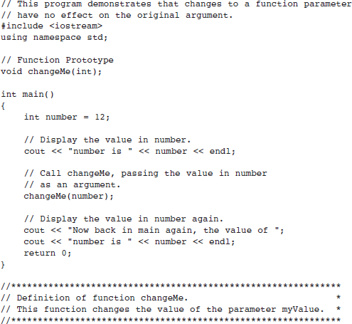
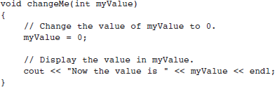

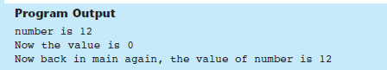
Even though the parameter variable myValue is changed in the changeMe function, the argument number is not modified. The myValue variable contains only a copy of the number variable. The changeMe function does not have access to the original argument. When only a copy of an argument is passed to a function, it is said to be passed by value. This is because the function receives a copy of the argument’s value and does not have access to the original argument.
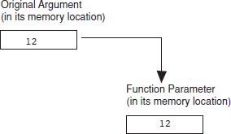

Using Reference Variables as Parameters
When used as parameters, reference variables allow a function to access the parameter’s original argument. Changes to the parameter are also made to the argument.
Earlier you saw that arguments are normally passed to a function by value, and that the function cannot change the source of the argument. C++ provides a special type of variable called a reference variable that, when used as a function parameter, allows access to the original argument. A reference variable is an alias for another variable. Any changes made to the reference variable are actually performed on the variable for which it is an alias. By using a reference variable as a parameter, a function may change a variable that is defined in another function. Reference variables are defined like regular variables, except you place an ampersand (&) in front of the name. For example, the following function definition makes the parameter refVar a reference variable:
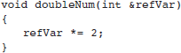
This function doubles refVar by multiplying it by 2. Since refVar is a reference variable, this action is actually performed on the variable that was passed to the function as an argument. When prototyping a function with a reference variable, be sure to include the ampersand after the data type. Here is the prototype for the doubleNum function:
void doubleNum(int &);

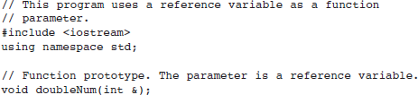
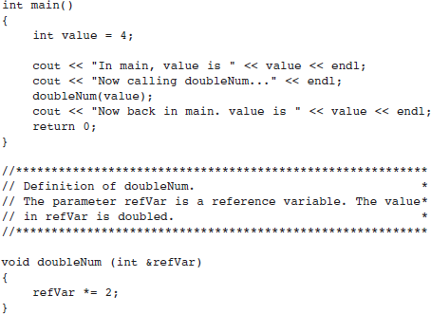
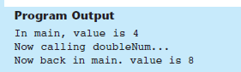

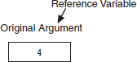

Practice Task
The following program asks the user to enter two numbers. What is the output of the program if the user enters 12 and 14?
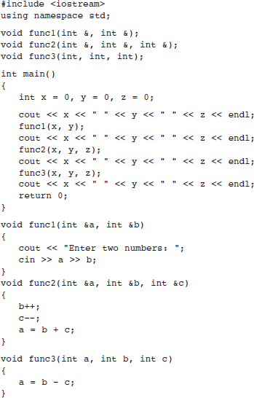

Task1
Write a function that takes two integers by reference and reverses their values individually.
Example:
Input: a = 12, b = 45
Output: a = 21, b = 54
Function:
void reverse(int &a, int &b);

Task2

Write a function that calculates the total surface area of a cylinder. The function should take radius and height as input parameters (passed by value) and return the calculated area.

Hint:
- Use the formula:
Surface Area=2πr(h+r)
- Since the values are passed by value, the original variables should not be modified.

Function Prototype:
float areaCylinder(float radius, float height);

Example
Input:
radius = 7, height = 10
Output:
Surface Area = 748

Task3
Write a C++ function named raiseSalary that takes a reference to a float variable called salary and increases its value by 10%.
Your function should directly modify the original variable using pass-by-reference.
Requirements:
- Function signature: void raiseSalary(float &salary)
- The function should increase the salary by 10%
- No return value is required

Example:
- Input: salary = 50000
- After function call: salary = 55000
Task:
Implement the function and demonstrate its usage in main() by taking a salary input from the user, applying the function, and displaying the updated salary.

Task 4
Write a function that takes two integers a and b as arguments (passed by value) and returns the result of the following expression:
Result=a² + b² + 2ab
Call this function from main() and print the result.

Hint:
- Recognize the identity:
a² + b² + 2ab = (a+b)²
- Use multiplication instead of any built-in power function if needed.
- Since parameters are passed by value, original variables will not change.

Function:
int computeExpression(int a, int b);

Example:
Input:
a = 6, b = 4
Output:
Result = 100

Task 5

Write a function that takes a student’s marks by reference and updates them based on the following conditions:
- If marks are less than 50, add 10 bonus marks
- If marks are between 50 and 80, add 5 bonus marks
- If marks are above 80, add 2 bonus marks
Call this function from main() and display the updated marks.

Hint:
- Use if-else conditions
- Since the parameter is passed by reference, the original variable will be modified directly

Function:
void updateGrades(int &marks);

Example
Input:
marks = 85
Output:
Updated marks = 87

